

School of Electrical and Information Engineering
University of the Witwatersrand, Johannesburg

ELEN3017 – Electrical Engineering Design

Phase 2: Final Report – 2021 Date: 26 April 2021

Name 1: Nduvho Ramashia | Name 2:
Student Number 1: 1490804 | Student Number 2:
Group: 58

1. Introduction

This document details the process taken in designing a 5V_{DC} bus voltage linear power supply. The power supply is to be used by an old pensioner to power up their small radio, which they received from their grandchild. The pensioner lives in a 230V mains AC voltage home.

Section 2 details the design specifics. The following section, section 3 shows the design and its details. It is followed by the section by the simulation results section, which shows what the design looked like in a simulation program, as well as how it behaved, that is section 4. After that is section 5, which shows the final built power supply prototype, its behavior, and characteristics.

2. Design requirements

The power supply is to have an output voltage of 5V_{DC}. It is also to be able to supply a minimum current of 500mA so it can be able to power the pensioner’s radio.
To aid with providing the desired 5V_{DC}, a transformer was provided. The provided transformer had multiple output voltages, of which the minimum was 6V_{rms}. Also provided were basic components including diodes, capacitors, regulator integrated circuits (ICs), and resisters.
To achieve the power required by the old pensioner’s radio, multiple voltage manipulation processes were required, which are shown in figure 1.

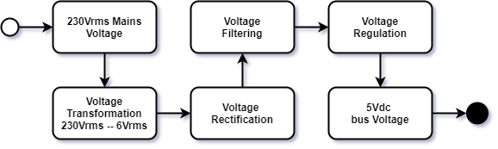

Figure 1: 230V mains voltage to 5Vdc conversion steps.

To diodes made bridge rectifier circuit is to used to rectify the AC voltage from the transformer. Capacitors are used to filter the rectified voltage, which is then regulated using +5V regulator IC.

3. Power Supply Design

Figure 2 shows the complete power supply design circuitry. The 6V_{rms} line voltage from the transformer was providing enough voltage after the rectifier circuit, to the regulator circuit, for the regulator to perform well and stable. Given it was providing sufficient voltage for the regulator and also resulting in the minimum power loss across the 5V regulator, it was chosen and used instead of its higher voltage alternatives. The less power loss also eliminated the need for a heat sink, which saved space and the overall cost of the power supply.

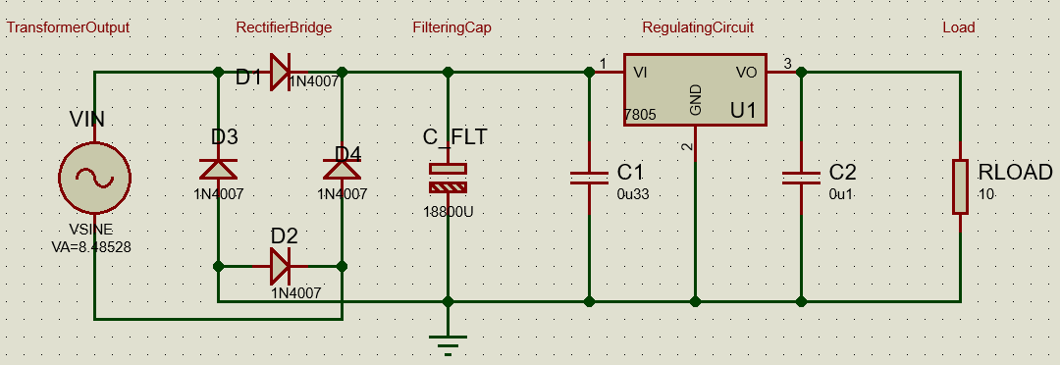

Figure 2: 230V_{AC} to 5V_{DC} power supply circuitry.

The rectification was achieved using a full-wave bridge rectifier for its superior effectiveness over the center-tapped rectifier. It provides a larger DC(average) output voltage compared to the center-tapped rectifier.
To make sure the power supply is less prone to failure, the 1N4007 diodes were used because of their high current rating, meaning they will be safe even when high current surges flow through them.
The 1.5A rated L7805 voltage regulator was used to regulate the filtered voltage, along with its input and output capacitor for filtering high-frequency noise.

4. Simulation Results

After building the circuit on a simulator, the voltage waveforms in figure 3 were obtained. The blue waveform shows the voltage waveform of the input into the bridge rectifier. The blue one of the voltage after the full-wave bridge rectifier, after which a voltage of 2*0.6V drops. The voltage after the rectifier is expected to be about 7.285V, which it appears to be.

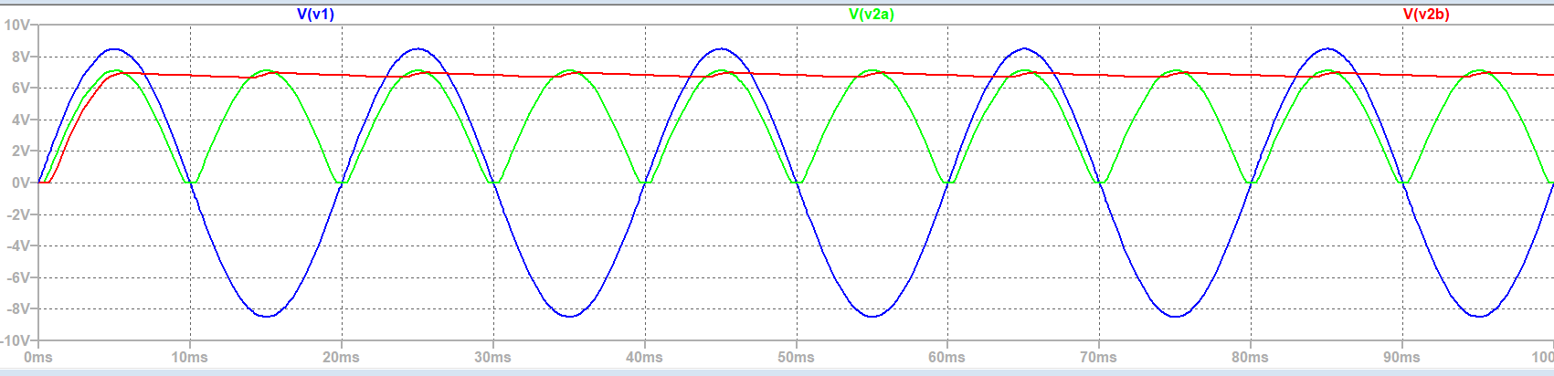
Figure 3: Voltage waveforms at different stages of the power supply.

The red waveform shows the voltage of the power supply after adding a smoothing circuitry.

5. Prototype Power Supply

Figure 4 shows the prototype put together.

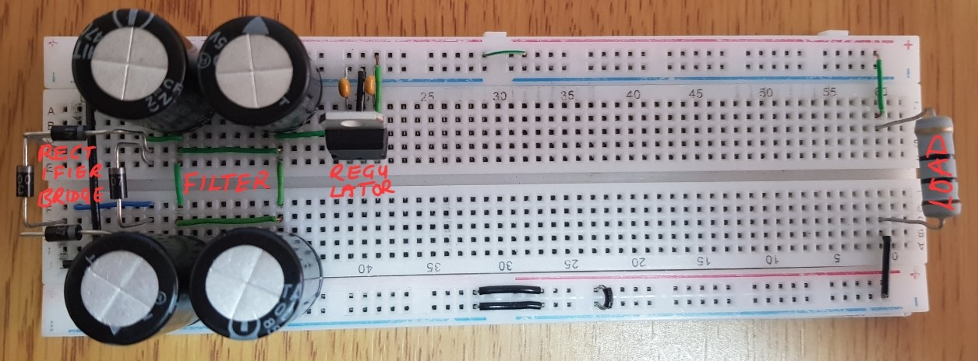

Figure 4: The prototype

Table 1 contains the voltages from different stages of the power supply. It shows the comparison between the calculated or expected voltages against the measured voltages.

Table 1: Calculated and measured power supply voltages.

 | Calculated (V) | Measured (V)
V1 | 8.485 | 9.4
V2a | 7.285 | 8.1
V2b | 7.285peak | 8.1peak

5.1 Power Supply Specifications

The overall specifications of the power supply are presented in table 2.

Table 2: Power Supply Specifications.

 | Rating
Rated Voltage | 5 V
Rated Current | 1.5 A
Rated Power | 7.5 VA
Input Voltage | 230V @ 50Hz

6. Discussion

The results from the simulation after the bridge rectifier were different from what was calculated. This was because of the different ‘diode voltage drops’.
Some voltages from the simulation were also different from what was observed experimentally on the design prototype. This was mainly because of the inaccurate transformer output voltage. It was expected to be 6.00V_{rms}, but was measured to be 6.67Vrms.

The designed prototype meets the expected 5V bus voltage and the minimum 500mA current. Although the voltage for the load required to draw 500mA, the voltage had an unexpectedly higher ripple voltage. The current drawn was also a little lower by a few milliamps than what was expected, which was mainly because of the resister’s inaccurate resistance.
The designed prototype can be designed to use a pi filter instead of capacitors only. A foldback current limit can also be integrated onto the circuit for a more power-efficient short-circuit and current limiting circuitry. The prototype performed fairly excellent.

7. Conclusions

The designed power supply used the full-wave bridge rectifier as its rectifier. It used a set of parallel capacitors to simulate a large capacitor. It also made use of a +5V voltage regulator.
Because of the practical transformer’s voltage which was higher than expected by 0.67Vrms, the measured voltage at some stages was too higher than expected.

The power supply met the requirement set at the beginning of the design. The current was however a few milliamperes lower than the expected 500mA, which was mainly due to the resister’s tolerance and the voltage’s ripple voltage not being insignificant enough even though it was small.

Appendix A

The tasks during the design of the power supply were divided as indicated below.

Task | Member
Circuit Design | Nduvho Ramashia
Circuit Analysis | Nduvho Ramashia
Circuit simulation | Nduvho Ramashia
Simulation analysis | Nduvho Ramashia
Circuit building | Nduvho Ramashia
Circuit testing and analysis | Nduvho Ramashia
Report composition | Nduvho Ramashia

